VBCS Training Lab 01   
Building Your First Application

# Introduction

Visual Builder Cloud Service (VBCS) allows you to rapidly create and host engaging business applications with a visual development environment right from the comfort of your browser.

In this hands-on-lab, we run through the basics of building a CRUD UI over a set of Business Objects that are already defined.

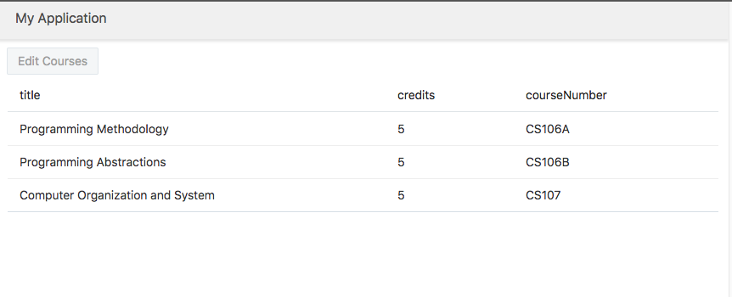

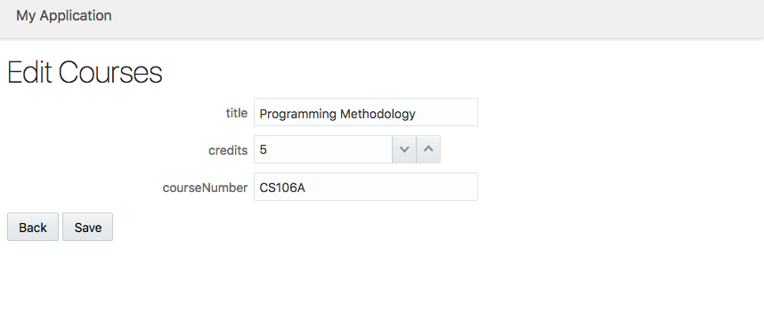

# Hands on Lab Instructions

## Creating a Web Application

First let’s import a project that already has an object model for a university’s course catalog.

1. Login to your VBCS instance.
2. Click Import
3. Drag and drop VBCS-Lab01.zip into the dialog box
4. Append your username to the Application ID to make it unique – i.e. VBCSLab01-*MyName*
5. Click Finish

### Adding a Table of Courses

1. In the left panel under Web Apps, double-click start  
   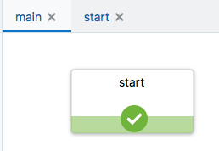
2. Drag a Table component onto the page
3. In the Property Inspector, click Add Data.  
   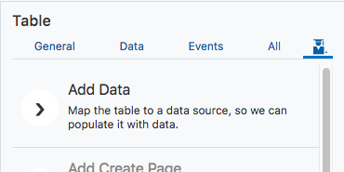
4. In the wizard, select Business Objects > Courses > getall_Course. Click Next  
   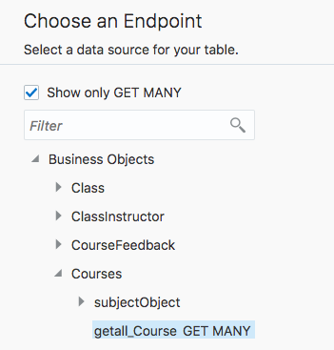
5. Select title, credits, and courseNumber from the Endpoint Structure. Rearrange as shown below and click Next.   
   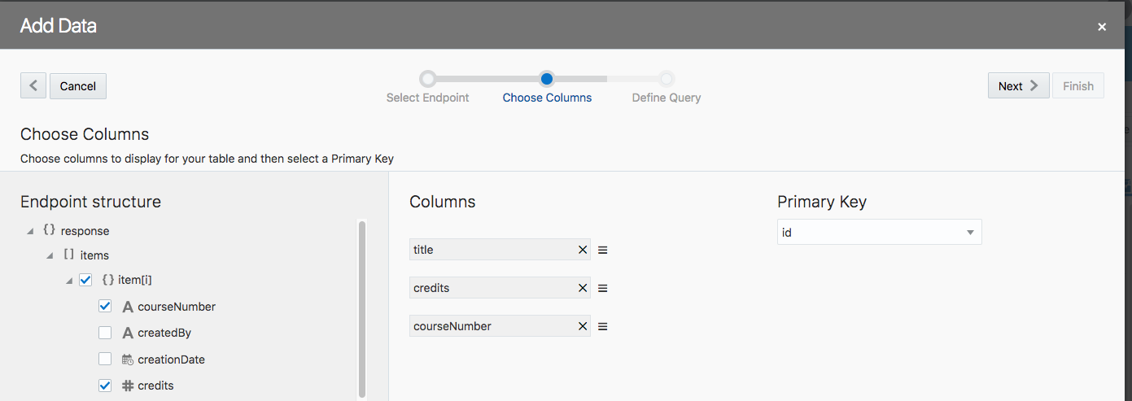
6. Click Finish. The table is populated with data.

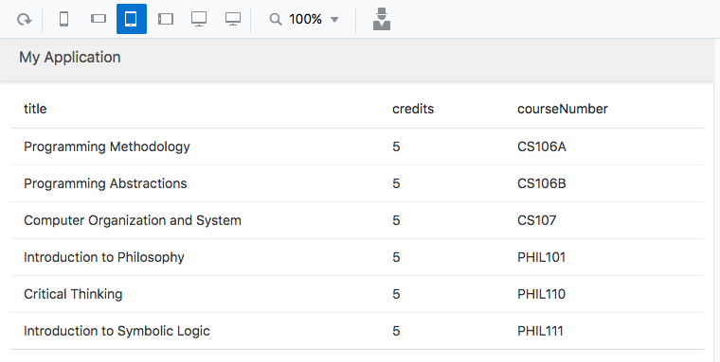

### Add an Edit Page

1. Select the table again. In the Property Inspector click Add Edit Page
2. Leave get_Course selected as the Read endpoint and click Next.
3. Leave update_Course selected as the Update endpoint and click Next
4. Select title, credits, and courseNumber under Select Fields. Click Finish.
5. Switch the Page Designer into Live Mode.   
   ../../Screenshots/Screen%20Shot%202018-02-13%20at%203.16.17%20PM.png
6. Select a row in the Courses table and click Edit Courses. The Edit page opens in another tab.  
   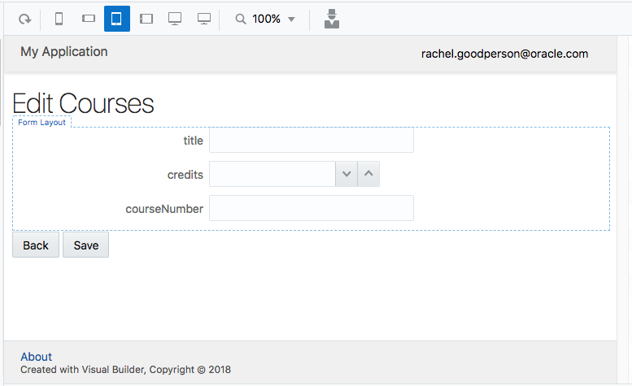

# Conclusion

Oracle Visual Builder Cloud Service is one of the fastest ways to develop and deploy an application to nearly any platform. Whether you are a seasoned application developer or have no technical background at all, VBCS gives you the ability to work with and share data more efficiently than ever before.

Be sure to visit the Oracle VBCS web site to get the latest details about this revolutionary application development tool and many other Oracle Cloud offerings.

<https://cloud.oracle.com/visual-builder>